Effect of absorbents on the removal of Dichloromethane
Time | %Removal of AC | %Removal of Bentonite | %Removal of Chitosan | %Removal of  5g AC/3g B/2g C) | %Removal of  5g AC/3g C/2g B | %Removal of  6g AC/2g B/2g C
0 | 0 | 0 | 0 | 0 | 0 | 0
20 | 24.45 | 21.03 | 44.65 | 41.42 | 41.69 | 60.26
30 | 36.18 | 26.64 | 48.34 | 44.76 | 55.82 | 72.99
60 | 42.33 | 35.85 | 57.99 | 55.33 | 59.50 | 80.03
90 | 45.21 | 37.90 | 57.99 | 55.33 | 70.53 | 80.03
120 | 45.21 | 37.90 | 57.99 | 55.33 | 70.53 | 80.03
180 | 45.21 | 37.90 | 57.99 | 55.33 | 70.53 | 80.03

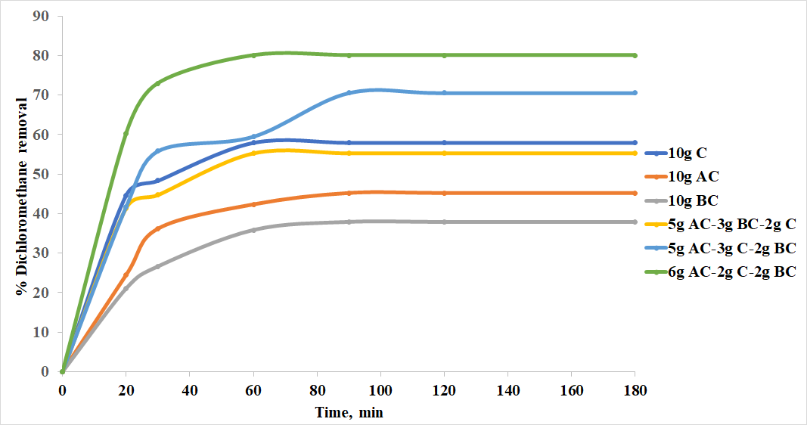
Effect of pH on the precursor´s samples and composites during the adsorption of dichloromethane.
 | Adsorption capacity of AC | Adsorption capacity of B | Adsorption capacity of C | Adsorption capacity of 5g AC/3g B/2g C) | Adsorption capacity of 5g AC/3g C/2g B | Adsorption capacity of 6g AC/2g B/2g C
0 | 0 | 0 | 0 | 0 | 0 | 0
2 | 4.60 | 5.74 | 6.23 | 6.59 | 7.00 | 7.59
4 | 5.74 | 7.63 | 8.06 | 6.84 | 7.14 | 8.39
6 | 7.08 | 7.84 | 8.35 | 9.83 | 11.31 | 12.67
8 | 9.73 | 10.13 | 10.34 | 11.24 | 11.90 | 13.91
10 | 12.27 | 12.02 | 12.39 | 13.46 | 12.72 | 14.66

